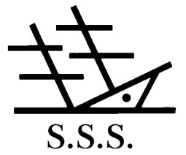**This is a Short History of Spalding Shipwreck Society**

This extract was taken from a Short History of Spalding Shipwreck Society by M. J. Elsden to commemorate the 150th Anniversary in January 1994. It’s published by the kind permission of the Society.

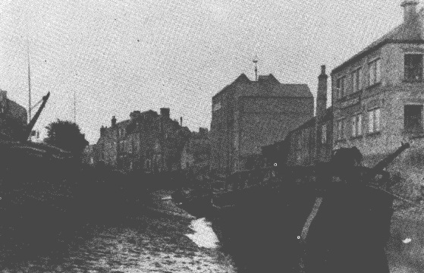The Spalding Society for Mutual Relief in Case of Shipwreck', or as it is known locally, The Spalding Shipwreck Society', is a reminder of the days when the town of Spalding was a thriving port. For hundreds of years the River Welland, which was navigable from Spalding to the sea, provided a life-line for the transport of coal and goods into the area; and also the means of sending produce and other goods out of Spalding to other ports in this country, and abroad. At times the Welland would silt up, and then larger ships would unload on to smaller vessels at Fosdyke, which in turn would continue the voyage up river to Spalding. In the early part of the 19th century vessels of 50 to 60 tons could get up river as far as Spalding. Records show that in 1829, 250 vessels brought goods into the port and 143 exported out of Spalding. By 1833 the numbers had increased, and there were 462 vessels in and 282 carried goods out of the port. With the coming of the railway to Spalding in 1848 the river trade began to decrease. Efforts were made to encourage the use of the port, and with improvements to the watercourse larger vessels were able to come up river to Spalding. In 1892 sloops and barges up to 120 tons could come as far as the town's High Bridge.

The following article from a local newspaper of that time called 'The Bee" gives a report of the shipping news for December 3rd 1830. Ship News.

Arrived – Mayflour, Gregory; Industry, Booth; Ann & Elizabeth, Gostelow; and Unity, Bear from Goole; Sovereign, Barker from Stockton; and Thomas & Ann, Bartrup from Selby, all with coal. Dove, Lowry, sen., and Martha, Lowry, jnr., from Hull with goods deals & c.

Sailed - Bee, Boyce; Thomas and Jane, Seymour; Triton, Knight; Albion, Ward; John & Maria, Jackson; and Good Intent, Barton; from Selby, all with wheat. Industry, Wright; for Goole, with potatoes. Wellington, White; with oats, both for London.

The riverside in these times must have been a hive of industry with vessels loading and unloading at the various warehouses that lined the river banks. Traces of these buildings can still be found. Public Houses were popular with the crews and bargees. Some of these had names associated with the port. e.g. The Barge-Ship Active-Ship Albion-The Crane and The Anchor.

The financial security of the sea-farers was a very chancey affair, and it was because of this that the Friendly Societies began to be set up as a means of helping sailors, and their families in times of trouble. On 2nd September, 1844 the "Spalding Society for Mutual Relief in Case of Shipwreck" was formed. This Society was one of 33 similar organisations set up around the coast for the benefit of sea-farers. Today the Spalding Shipwreck Society is the only thriving one still in existence out of all those that were started. Applicants for membership of the Society must have reached the age of 16 years, and fall into one of two categories, either Benefit Members or Honorary Members. Benefit Members consist of those who have earned their livelihood from the sea, and Honorary Members are those who have an interest in the Societies wellbeing. The subscriptions at the present time are £1.25 annually for Benefit Members, and £1.00 annually for Honorary Members. All subscriptions are due on the 1st January each year. A set of 27 rules were set out, and there have been slight amendments, but they are basically the same as when they were drawn up 150 years ago. Compensation up to a total of £10.00 was paid to any Benefit Member deprived by shipwreck, and should loss of life occur, the widow qualified for a lifetime pension of 1 shilling per week or a lump sum of £10.00 in full settlement instead. Today this may seem a rather derisory amount, but back in the days when the Shipwreck Society was first formed this sum would make quite a difference to people’s lives. Unfortunately the earliest minute books of the Society are missing, but from 1912 onwards they are complete. Much of the contents of these books are purely of a business nature and not of particular interest to most people, but the report for the year 1916, being in the middle of the First World War is of more interest:-

The Spalding Shipwreck Society Report for the year 1916.

The committee in presenting the 72nd Annual Balance Sheet of this Society for the past year 1916, do so with some pleasure especially at a time when the Great European War has entered its 3rd year, and still raging on both Land and Sea, also in oceans outside the War Zone, and the most destructive machinery employed to destroy the Mercantile Shipping of Great Britain, in which many of our Members are employed in, and considering the risk they run by either being blown up by the German submarines or the floating mines laying around our shores, entailing a considerable loss of life to the population employed in navigation of the sea. The committee have only one claim for loss by sinking of a steamer by a German submarine; one death by the sinking of a ship in a gale, off the Norfolk coast in the month of February last.

The funds show a decrease of 8/10d after usual bonus amounting to £10-l-3d has been returned off the annual subscriptions paid by Sailor Benefit Members, who have been ten years Members of the Society, also 13/4d written off the War Loan. The number of widows receiving Benefit from the Society's funds during the year are 5; viz:- Four Widows received a weekly pension of 1/- per week and one widow took the lump sum of £10 instead of the weekly pension. The usual Christmas Gifts of £10 to the Widows in receipt of Pension. The funds invested amount to £1364, together with cash in hand amount to £1400. The usual Subscriptions and Donations have been made to the various Societies during the past year.

There has been one death during the year, J.B. Binks.

C. Dalrymple Hall - Hon. Secretary.

In 1917 the minute book recorded 4 deaths, J.C. Hack, Tom Scott, Wm. Royce, and H. Mountain.

In 1918 there were 2 deaths, Stephen Dunn and Charles Upcraft.

In 1919 minutes also recorded 2 deaths, William Horton and William Dring.

In 1924 the Society reached its 80th year. There had been one death: Mr. John William James, who was lost in the S.S. Rose near Portland in the English Channel. There were 9 widows in receipt of pensions. The usual Christmas Box of £1 was granted to the widows.

Financially the Society has survived, but it was reported that in 1868 with one orphan and eleven widows to support, the annual accounts showed a loss of £10-5-3d. in spite of 60 Benefit Members subscribing to the funds.

In the following year steps were taken to ease the finances and the South Holland Magazine in May 1869 gave the following report:-

Spalding Shipwreck Society:- A literary and musical entertainment was given at the Exchange Hall on the 8th April, by amateurs, in aid of the funds of the society. There was a fair attendance though by no means a 'full house'. The various performers went through their parts with great credit, and those present by the warmth of their applause showed how thoroughly they appreciated the effort made to amuse and instruct them. Dr. Morris occupied the chair and in his opening remarks eloquently dwelt upon the perils and dangers of those who 'go down to the sea in great ships' and upon the advantages such a Society conferred on its members.

No record can be found as to how much this event made, but in 1890 the Secretary Mr. Capps reported that the Society's assets amounted to £979 and it had a membership list of 53.

Today the Membership is 70 Benefit and 150 Honorary Members. The Widows Christmas Bonus which for many years was £1 per person now stands at £50 and in 1993 there were 9 widows receiving this sum.

From 1844 when the Society was founded until February 1977 the Ship Albion public house in Albion Street was the Society's Headquarters, and a succession of landlords has been pleased to accommodate the meetings. Some landlords even became members, as was Mr. Thomas Draper who acted as President of the Society in 1850. Benefit Member, Robert Hutchinson married the landlord's daughter Ellen Draper.

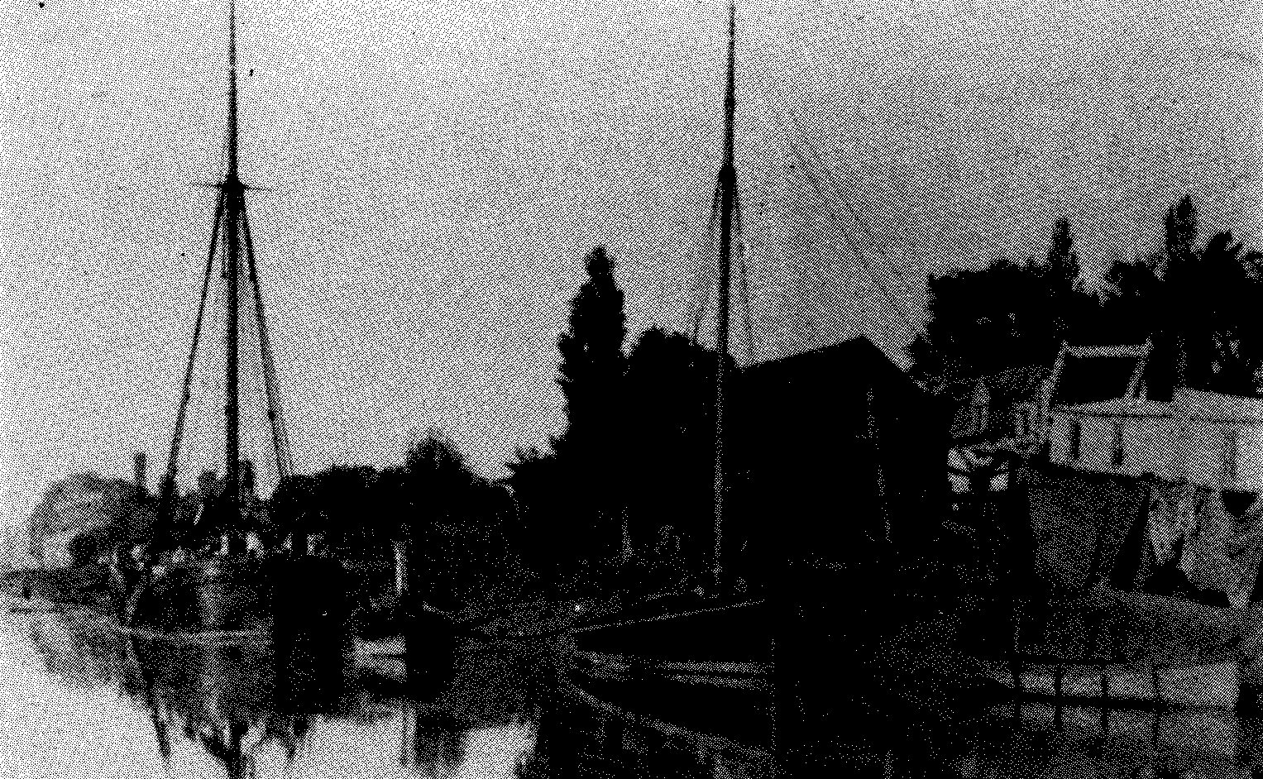The Annual Dinner has always been a very popular event, and apart from the War Years, it appears that it has always taken place throughout the history of the Society. Currently the Annual Dinner is held at the Springfields Restaurant as are the Quarterly Meetings and Annual General Meetings. Each meeting is preceded by a sausage supper. In the days when the port was in operation one of the requirements when fixing that date was the 'the state of the tide was right', so that those who earned their livelihoods on the water could be home for the great occasion.

Pannell's boatyard and slip situated on the banks of the River Welland along Albion St

The Spalding Free Press of 20th January 1891 recorded the annual meeting and supper;-

"Shipwreck Society'. The annual meeting and supper of the Spalding Shipwreck Society were held at the Ship Albion on Friday evening last. Mr. W.W. Copeland occupied the chair and amongst those present were, Mr. J.T. Atton, Mr. W. Stubbs, M.E. Caulton, Mr. Grimby, Mr. T. Upton, Mr. T. Stubbs, Mr. E. Richardson, Mr. Gostelow, and a good attendance of sailor members and supporters of the Society. A capital spread was provided for the occasion, and after supper the secretary Mr. C.D. Hall, read the annual report, which showed that the funds of the Society amounted to just over £1000, £900 of which was invested and £100 in the bank, being a gain of this year of over £20. The sailor members numbered 54 being the same number as last year. The number of widows in receipt of pension at the present time is ten. Mr. Samuel Kingston was elected President of the Society for the ensuing year, and the whole of the officers and committee were re-elected. A pleasant social evening was spent, songs were sung by some members and visitors, the usual loyal toasts were duly honoured, as were the "Army, Navy and Volunteers", 'The Town and Trade of Spalding" and 'The Shipping Interests".

Over the years the records of the Society show many familiar Spalding names. Captain George Levesley was skipper of Mr. Henry Bugg's yacht. Mr. Bugg was the proprietor of the brewery later owned by Messrs. Soames & Co. Ltd., a very wealthy man, whose chief hobby was the sea. They would sail away from Fosdyke to various places on the Continent, where one could buy tobacco and spirits very cheaply, and as Mr. Bugg was a very popular and influential man in these parts, his yacht would not be so carefully examined by the Customs officers as would other craft, and his crew, knowing this, considerably augmented their income in consequence. A note scribbled on a Balance Sheet of 1903 refers to Captain George Levesley as "the grand old man of the Society". His grandson Fred Oliver Levesley was Vice President of the Society in the 1970's.

There were many notorious mariners of the Culpin family, and Richard Culpin followed Richard Culpin one generation after another. The Culpins traded

chiefly in pots and hardware, building a warehouse in Double Street to store what their ships had brought from Hull, Newcastle, etc. Mrs. Culpin often went to sea, and was very clever at hiding tobacco, etc., from the prying eyes of the Custom officers by concealing dutiable goods under her crinoline skirt. They did a prosperous trade in the town.

Captain Joe Gostelow was a popular skipper in these parts, the last of his line as a mariner trading from Spalding. He owned a ship called the 'Mary Jane", and was bringing a cargo of coals from Newcastle to the gas works at Spalding early in 1895, but he never arrived, for his vessel went down with all hands off the Humber. His crew of three were all local lads:- Simon Marsh, Lineham and Willcox.

The Royce's were a well-known family of mariners, there being many of that name engaged in our river trade and elsewhere. Tom Royce owned the "Roarer", which he lost; though he and his crew were saved, unfortunately the boat was not insured. He also owned the "Laurel" and "William Royce". Ted Royce had the "Hope", and Captain Turner, Tom Royce's stepbrother had the "Sarah" and "Violet". The death in 1925 of Joseph Royce, retired pilot from Fosdyke Bridge, ended a membership which had its beginnings in the late 1870's.

Tom Dunn owned a ship called the "Elizabeth Ann" and he was notorious for being the most careful skipper sailing from these parts, and if the weather did not look promising he would stay at the mouth of the river till it did.

Another Spalding skipper, Captain Walker, had his ship quarantined off Gravesend when taking a cargo to London, because one of his crew had smallpox. He also contracted the malady and died on board.

Mrs. Crookes, the wife of Captain Crookes, went down the river in a small boat with some friends to meet her husband's ship which was due, but the boat was caught in an exceptionally big eagre, near the mouth of the river, which threw Mrs. Crookes out, and she was drowned.

The Hayes family had connections with the Shipwreck Society for many years. John Hayes at his death in 1912, had been a member for over 40 years. Member brothers, Robert Arthur and John William Hayes, owned the steamer "Speedwell" which traded along the east coast until bought by the Admiralty during the First World War and used as part of Hull's boom defences.

One of the last vessels to supply goods to the town was the "Fern" skippered by its Spalding owner, Captain J.C. Atkins. He used to carry maize, cotton cake, wheat and coal which fed the Spalding Gas Works.

Mr. Fred Turner the present President of the Shipwreck Society is a grandson of early member Captain John Turner. On November 25th 1919 the following interview with Captain Turner was published in the Spalding Free Press, and gives a fascinating view of what life was like in the port in those days:-

'When the Welland was Busy' - Captain John Turner of Spalding (1839-1926). "When I first went to sea it was a rare thing to see a steamboat" said Captain John Turner, landlord of the Angel Inn, Double Street, Spalding, to a Free Press Representative. Captain Turner, who is hale and hearty at 80 years of age, is one of Spalding's grand old men and holds several interesting records. He is probably the oldest landlord in the town, having been associated with the Angel for 41 years; one of the oldest members and trustees of the Welland Lodge of Oddfellows; is Harbour Master for Spalding, and the oldest member in the town of the Spalding Shipwreck Society, his membership extending over 60 years. "When the Welland was Busy".

"My father-in-law put me in the Shipwreck Society when I was about 20 years old", said Captain Turner. "I was 18 years old when I went to sea in a sailing vessel. There was a nice trade done on the River Welland then, but not like there had been. There was a good trade in coals from the North of England, and foreign ships used to come up with deals to Fosdyke Bridge when there was a heavy drought of water. Our boats took cargoes of wheat and flour, and carrots in the Winter time. I have taken carrots and apples and different things to the North of England". "My mother once saw 39 vessels in the river, and there were 375 came up in one year. The biggest barge I ever remember coming up was the Harwich, laden with timber and flax. We baked a quarter of a ton of ships biscuits in one day for a vessel at Boston, which was going direct to Calcutta". "I was about 40 years in the trade, mostly to Middlesbrough, Sunderland, Seaham, London and on the coasting trade generally. My boat was the Sarah of 40 tons, which would load 70 tons. We would carry 20 quarters of wheat". "I can remember the chief captains of the old days: Sam Culpin, Gostelow, Hayes Royce, Chester, Joe Vine, Matthew Vine, and John and Joseph Atkin". "In the Baltic".

"As a young man I sailed as far as the Baltic ports, and the Mediterranean to Marseilles, and also to Dunkirk. We took coals and brought home wheat, deals and hemp. We made the voyage to Kronstadt in the Baltic, and back in eight weeks. Kronstadt was a busy port on the mouth of the Neva, with the capitol of Russia, St. Petersburg, twelve miles above. We could see the spires of that city on a clear day. About that time they did away with serfdom in Russia". 'The worst voyage I ever had was as a young man going to Colchester. We drove across the Scawby sands. I was in the rigging putting up the flag of distress. She struck a few times, but being loaded light got off again into deep water, and after dragging two miles, the anchor brought her up abreast of Yarmouth. When I was ashore that night, I heard a man saying in the street behind me, The ship was lost with all hands'. "We were taken in the sailors home at Yarmouth". "One of our

Spalding boats, John Gostelow's, was lost with all hands on a Christmas Eve, making haste to get home from the north. The Captain and three men were on board".

"The Shipwreck Society, started by, among other Captains Thos. Royce, George Levesley, and Gostelow, has done much good work in assisting shipwrecked Spalding men to replace their belongings, and also in helping the widows of the men". "My grandfather John Turner took part in a voyage of discovery. Two ships were fitted out by the King in 1791 and sailed to the Pacific, where for six years they were engaged on that work on the coast of Canada and the United States, and elsewhere ". A book was written on "John Turners Voyage Round the World", in five volumes about the size of a New Testament. We left Captain Turner seated in his arm chair by the side of a cheerful fire, living over gain in memory the scenes which his reminiscences had called up.

As we approach the 21st Century it is pleasing to see the Shipwreck Society thriving. The Welfare State is such that there is not so much need for a society of this type. Never-the-less so many old traditions and organisations have disappeared, and it would be a pity to see this fine old organisation go the same way as others. With a membership of over 200 the future looks good for the Spalding Society. Although Spalding is no longer a port; many people in the area still earn their livelihoods on the High Seas. Life on the seas is a lot safer than it was in years gone by, but accidents do still happen. When a Benefit Member dies either by accident or natural causes their widow still qualifies for the annual Christmas Bonus. Although this is not a large amount it is sufficient for a lady to get herself a little treat, and a reminder that the members of the Society do not forget her.

The Society has survived the last 150 years, and we hope and pray that in 150 years time the membership will still be as active.